Bio-Note

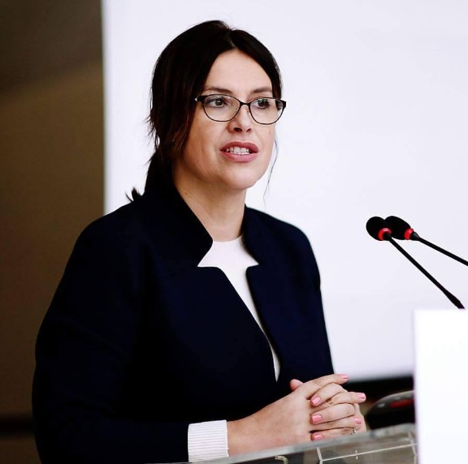

Name Gentiana Mara Sula
Institution Authority for Information on Former State Insurance Documents
Job title Chairwomen
E-mail gentjana.sula@gmail.com linkedin.com/in/gentiana-sula-028ab14
Academic title Doctor of Philosophy (PhD), Education Equity

Dr. Gentiana Mara Sula is the head of the Authority for Information on Former State Insurance Documents since the establishment of this institution, on November 16, 2016.

Previously, she was deputy minister of Social Welfare and Youth, where she had a significant role in advancing the country's agenda to face the communist past, including improving the compensation mechanism for former political prisoners and their families, preparing a the roadmap for the recovery of people disappeared during the dictatorship as well as leading the work to ensure access to the files of the former State Security, a law which the Parliament of Albania approved in the spring of 2015.

At the head of the Authority, Dr. Gentiana Sula has played an important role in opening the files of the former State Security, which operated during the communist regime in Albania, known for human rights violations and political repression. The opening of the Sigurimi files was a big step towards coming to terms with Albania's communist past and promoting transparency and accountability in the country.

The Authority for Information on Former Security Documents of the state in its direction is helping to raise awareness of the injustices of the past and promote the culture of human rights and democracy in Albania. By making AIDS files public, AIDS is contributing to transparency so that past crimes are not hidden under the rug or forgotten, promoting the establishment of a culture of accountability in order to prevent similar abuses from occurring in the future.

Its work consists in creating a space of dialogue and understanding between different groups of Albanian society in order to promote the feeling of national unity and to lead the country towards a more democratic and fairer future.

During her professional activity, she has managed important projects for the World Bank and UNICEF, in Albania and other countries in Eastern Europe and the Middle East, related to educational policies. In this field, she also holds the title of Dr.

For 11 years, she has been making her academic contribution as a lecturer at the University of Tirana, Faculty of Social Sciences in relation to topics on the gender aspects of human resource management and critical thinking.

She is a member of the Steering Committee of ENRS (European Memory Network) since 2017, where she represents Albania.

Dr. Gentiana Mara Sula comes from a Tirana family. She is married and has three children.

Award
"Golden Gratitude" "For the contribution given to the head of the Authority for Information on State Security Files in uncovering the crimes of communism; the discovery and evidence of the crimes of the communist dictatorship in the infamous internment camp in Tepelena, where many children and elderly people lost their lives.", Pan-Albanian Federation of America Vatra,Njew Jork, September 20, 2021.
“UET Appreciation Award", European University of tirana,' “For her contribution in building a modern, efficient and critical institution, in raising awareness of past injustices in Albania, in preserving collective memory and national unity, through the promotion of human rights, democracy, the culture of transparency and accountability.”Tirana 15.11.2023.

For futher information clik the link

